# Getting Started

Start ModelMuse, select “Create a new MODFLOW model” and click Next.

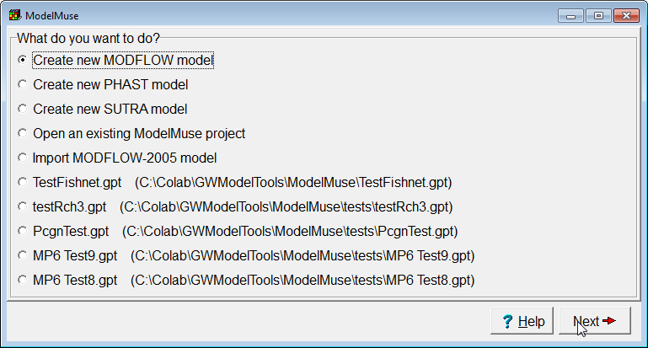

Set the number of layers to 1 and set the elevations of the top and bottom of the aquifer. You may also edit the name of the aquifer if you want to. Click “No Grid”. (We will create a grid after importing the base map.) If you haven’t watched it already it would be a good idea to watch the introductory video for ModelMuse at <http://water.usgs.gov/nrp/gwsoftware/ModelMuse/IntroductoryVideo/IntroductoryVideo.html>. This video will play in a web browser the first time you start ModelMuse.

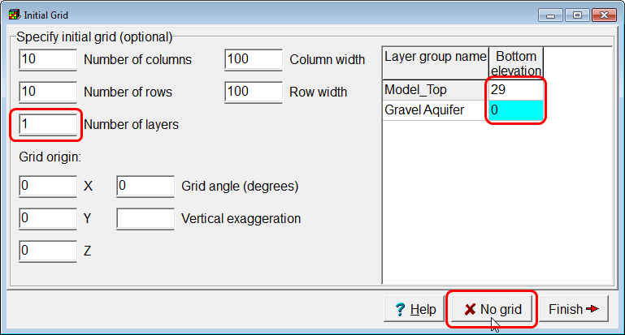

# Importing a Background Image

Select “File|Import|Image”  
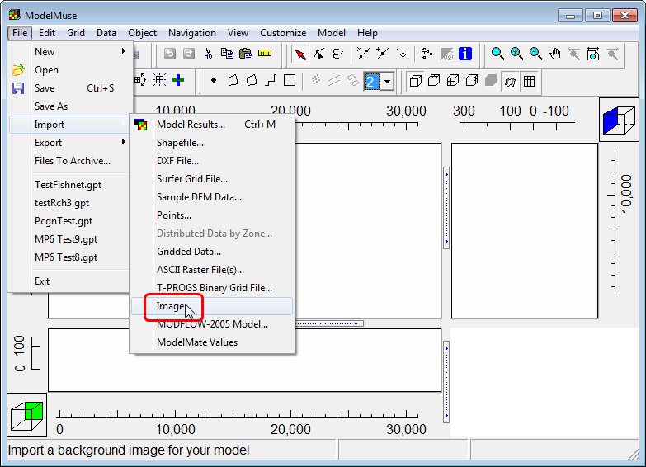

In the Import Image dialog box, click “Select image” and select the base map.  
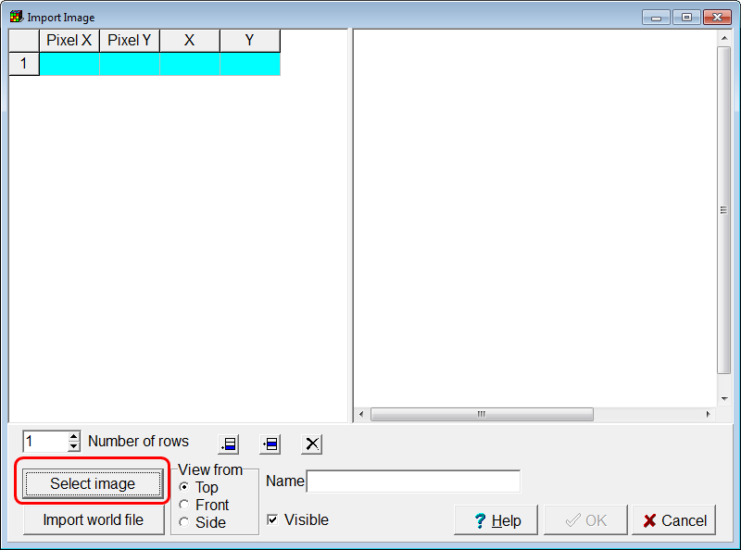

A message will appear telling you how to specify the location of the image. Click OK to dismiss the message.

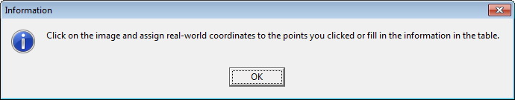

The image you selected will be displayed in the dialog box.

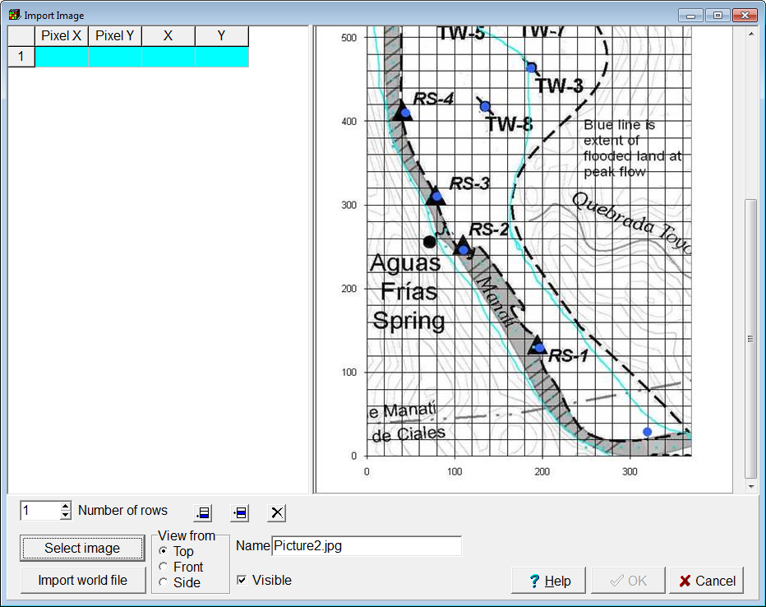

In the image, scroll down, and click at the location that has coordinates (0,0) and enter those coordinates in the dialog box.

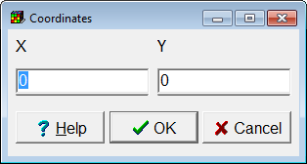

The coordinates will be displayed in the table in the dialog box. A small black dot will appear at the location in the image where you clicked.  
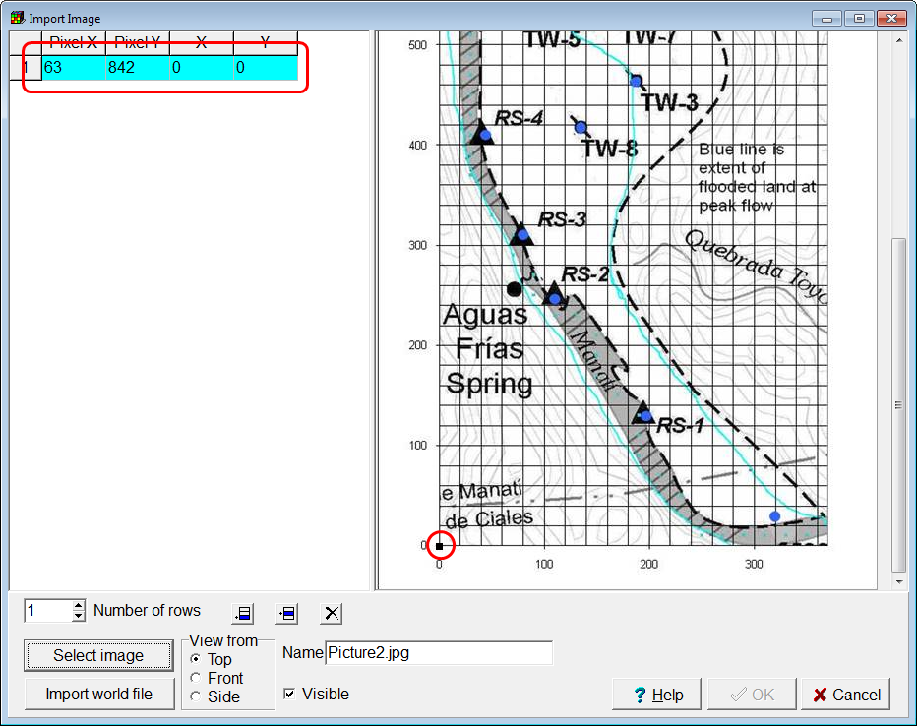

Now click in the upper right part of the image where the coordinates are (370,800) and enter those coordinates in the dialog box.

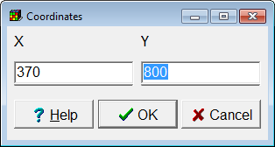

Those coordinates will appear in the table in the dialog box to and a second black dot will be displayed where you clicked. Click OK to close the dialog box and import the image.  
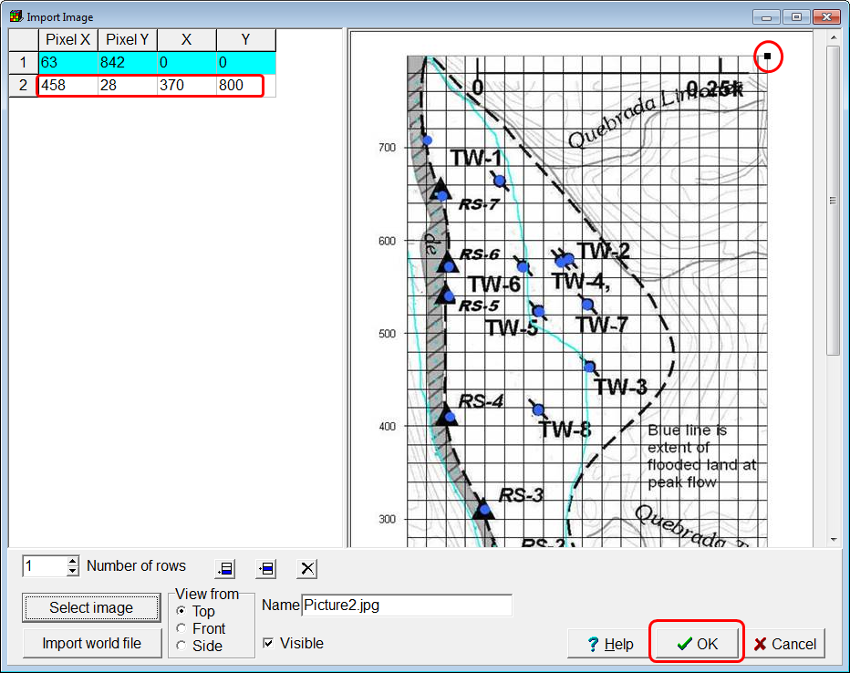

The image is too small to be visible at this scale so zoom in until you see it.   
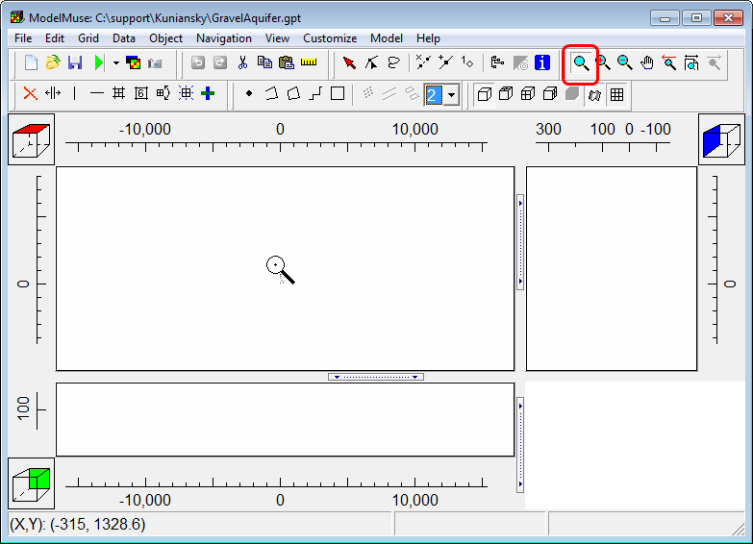

When you have zoomed in enough, you should see something like this.  
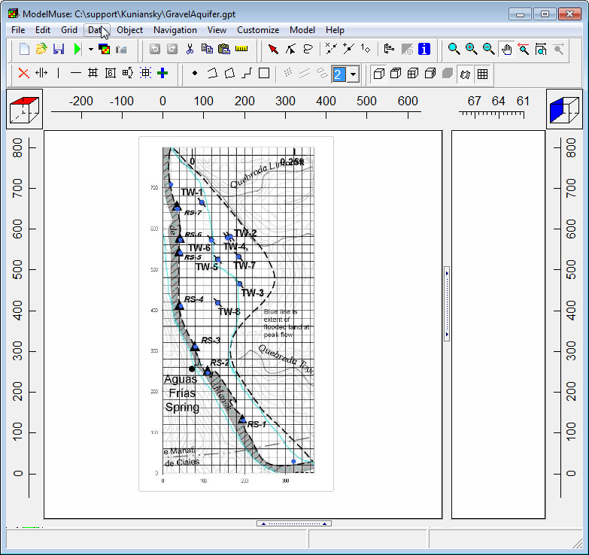

# Defining the Model Area and Generating the Grid

Click the **Create polygon object** button  and draw a polygon object around the area that will be part of the model.  
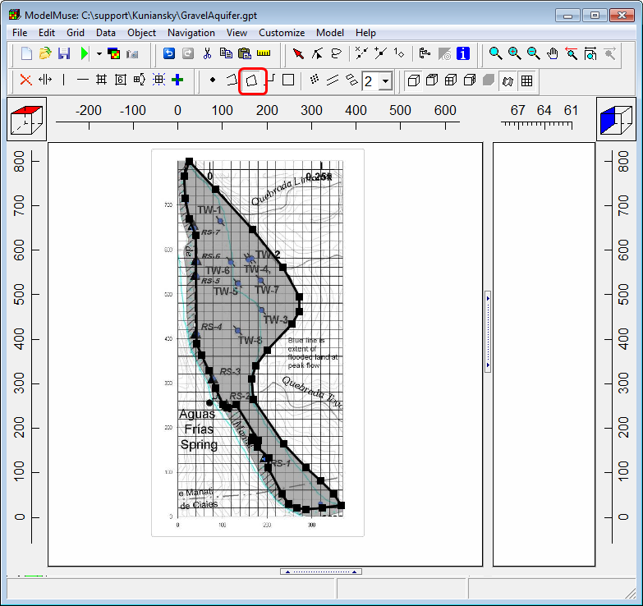

Use the object to set the grid cell size to 20. (You may want to specify a name for this object such as “ModelArea” to make this object easier to recognize later.)  
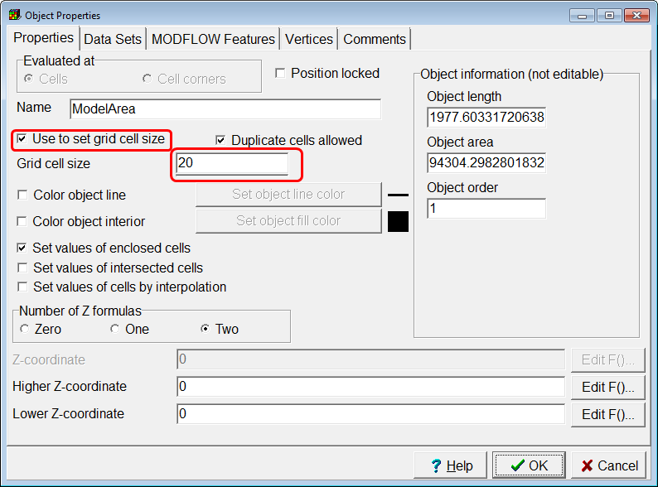

Now hide the background image (Edit|Show or Hide Image). We don’t need it for the next few steps. You can show it again later if you want to.

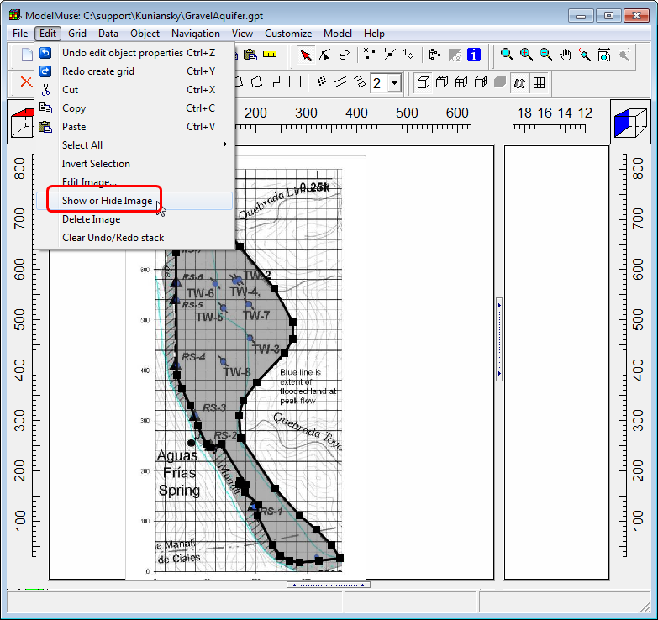

Select “Grid|Generate Grid…”  
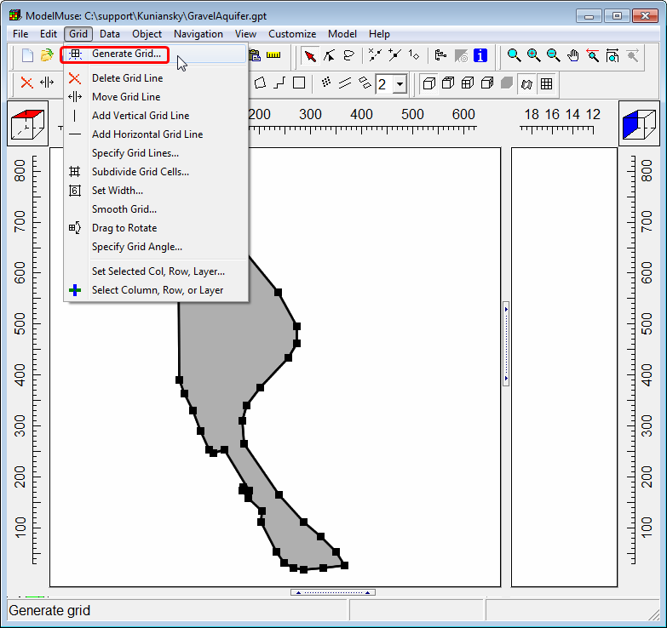

In the dialog box, uncheck “Calculate grid angle automatically”. Leave the grid angle set to 0 and click OK.

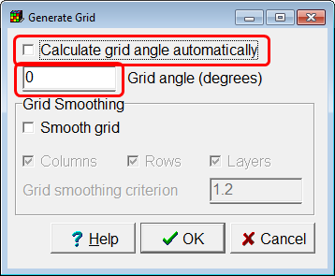

You should see a grid similar to this one.  
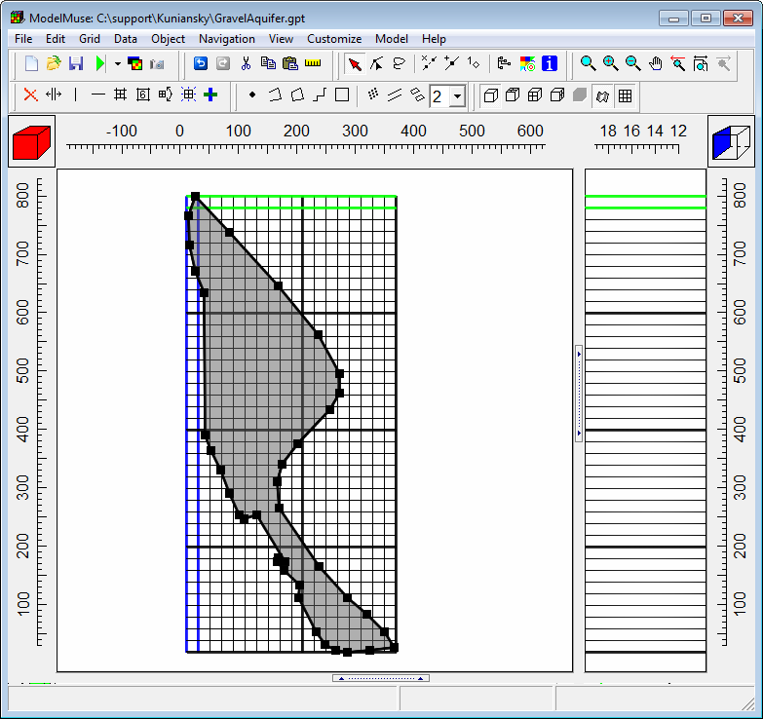

# Changing the Layer to Convertible

Select “Model|MODFLOW Layer Groups…” and change the aquifer to “Convertible”.

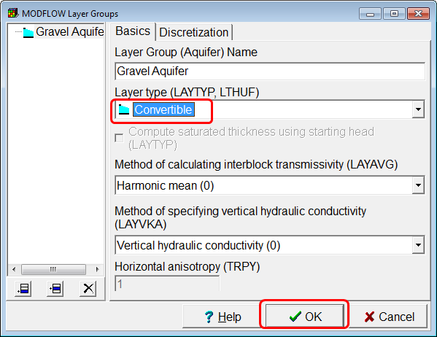

# Setting the Model Units

Select “Model|MODFLOW Options…”  
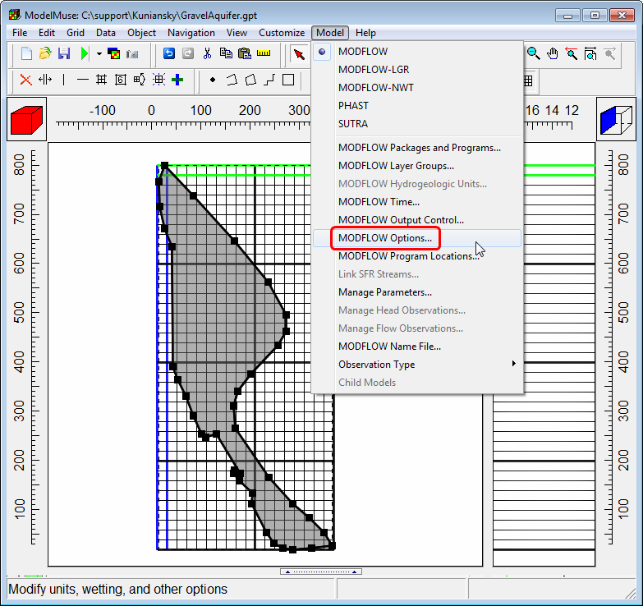

On the Options tab, set the time unit to days. Leave the length unit set at m and click OK.  
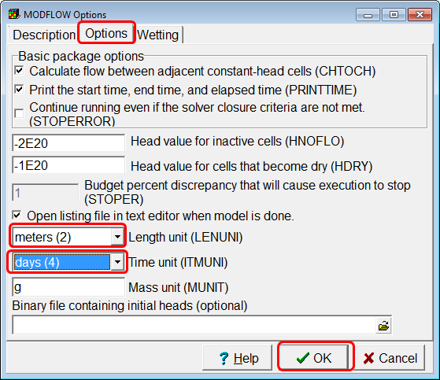

# Setting Default Values for Data Sets

Select “Data|Edit Data Sets…  
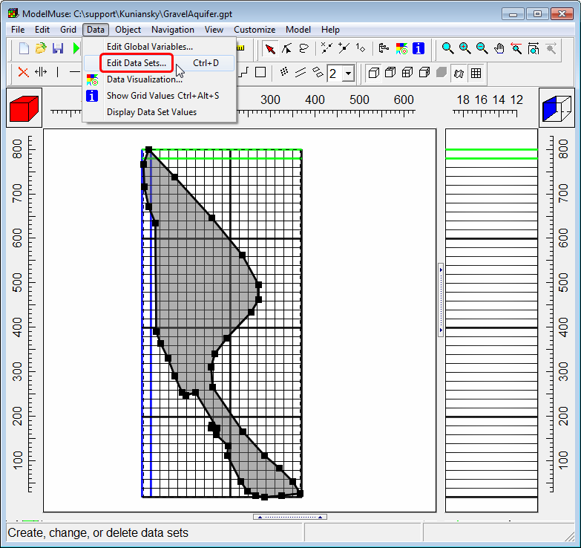

In the Data Sets dialog box, set “Active” to false. This will make all the cells inactive. Later on, we will use one or more objects to set some of the cells to active. 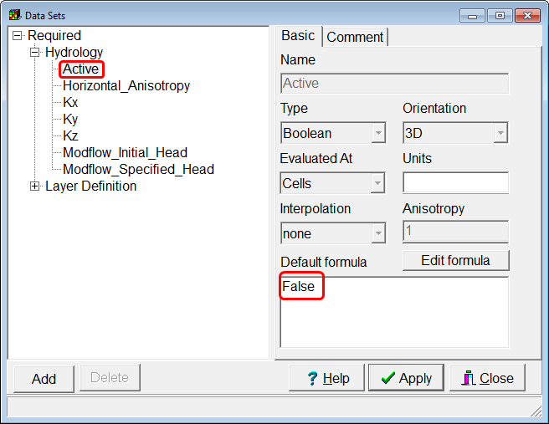

Set the initial head to 19.4.  
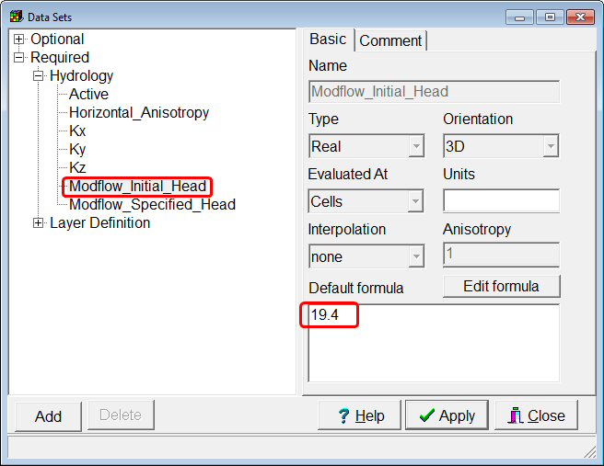

Set the hydraulic conductivity to 60 m/day and click Apply.  
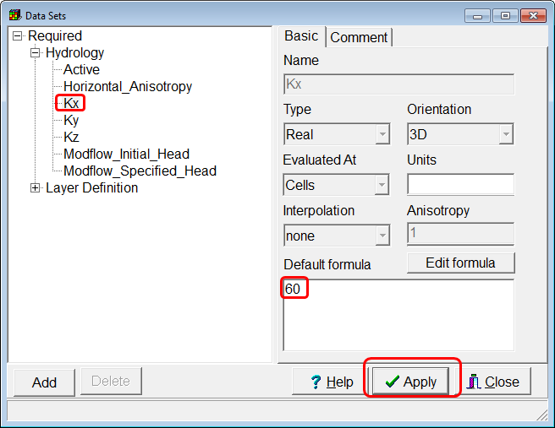

# Choosing Packages

Select Model|MODFLOW Packages and Programs…”  
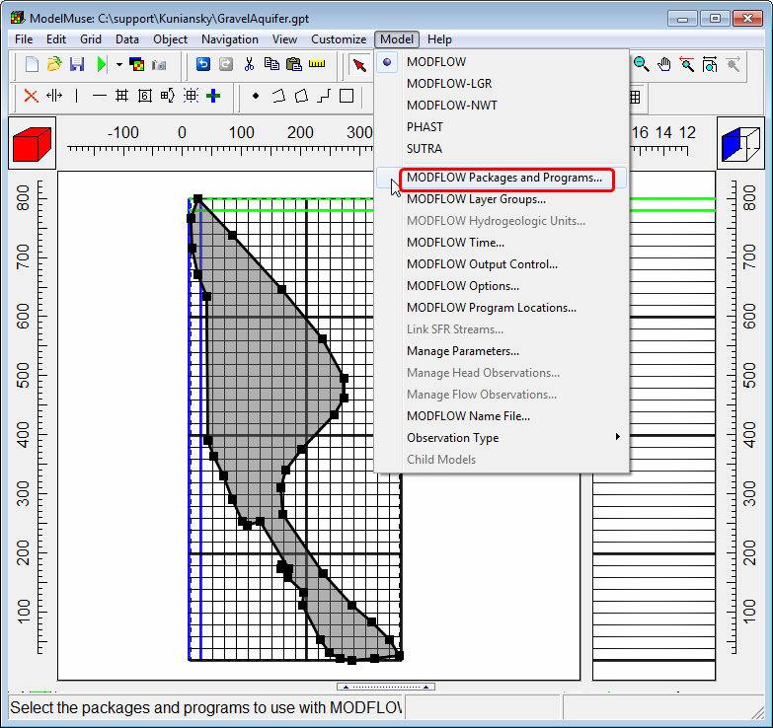

Activate the CHD and RCH packages and click OK.  
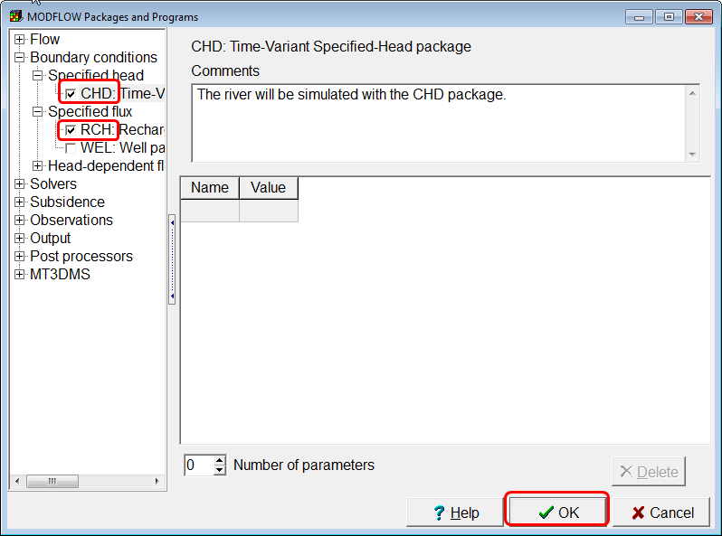

# Setting the Active Cells

Select “Object|Select Objects” and then double click on the object you used to specify the grid cell size. This object is a 3D object, it has an upper and lower surface which are specified by the “Higher Z-coordinate” and “Lower Z-Coordinate”. Right now both of those are set to 0. You need to change those. Click on the “Edit F()” button next to the formula for the “Higher Z-coordinate”.  
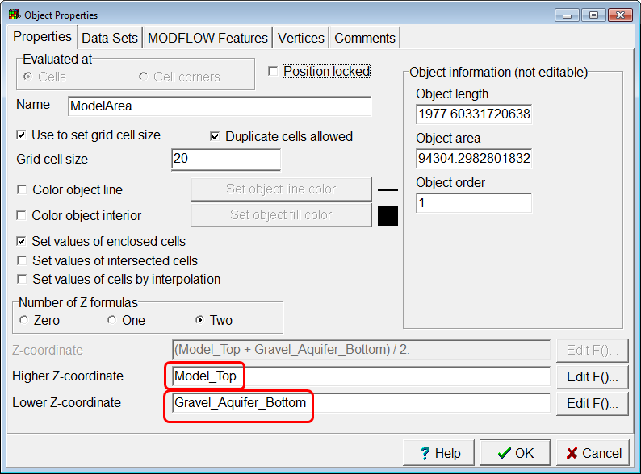

The Formula Editor will appear. In the tree view on the right, expand “Data Sets|Required|Layer Defination” and then double click on “Model_Top” to set the formula for the higher z-coordinate to the top of the model. Then click OK.  
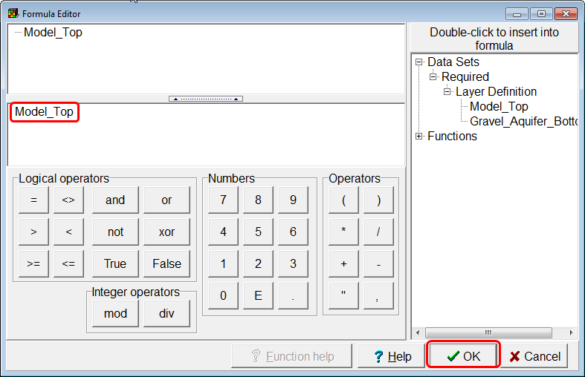

Repeat this process for the lower z-coordinate but set the formula to the data set for the bottom of the aquifer and click OK.  
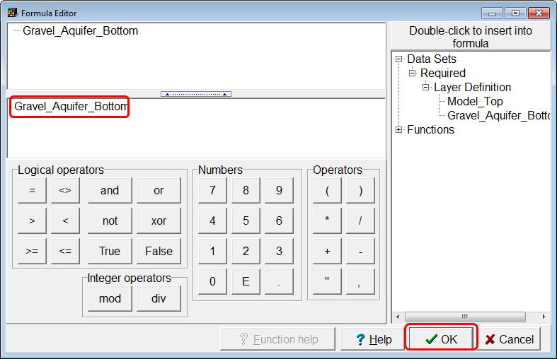

In the “Object Properties” dialog box, go to the Data Sets tab and set the formula for the Active data set to True. Then click OK.  
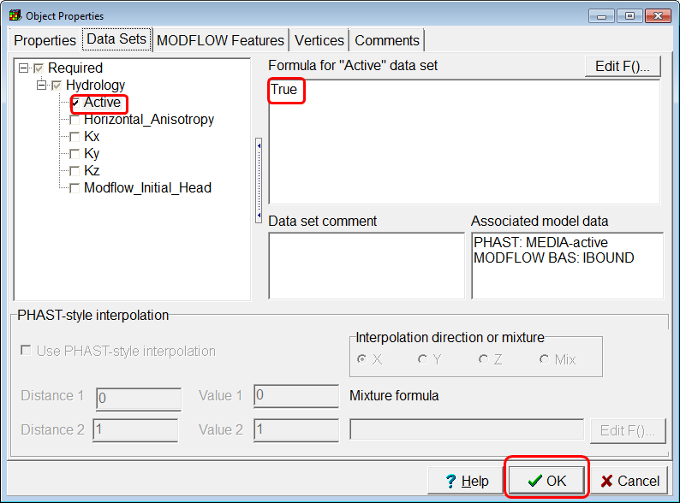

To check that the active cells have be set correct, select “View|Show or Hide 2D Grid|Show Active”.  
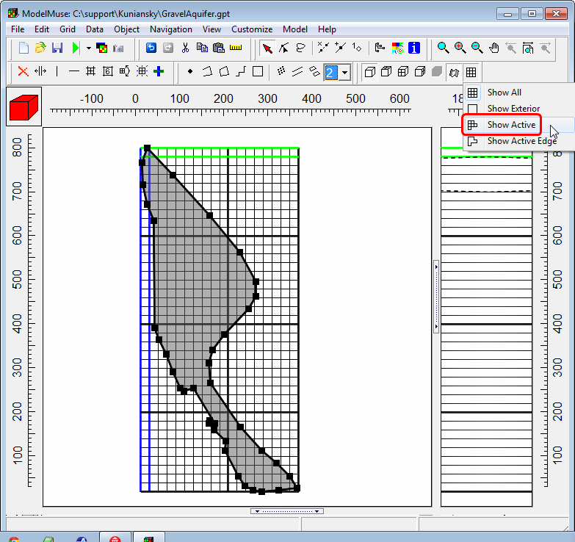

# Defining the Recharge Rate

Click the “Create rectangle object” button and draw a rectangular object that completely surrounds the grid.  
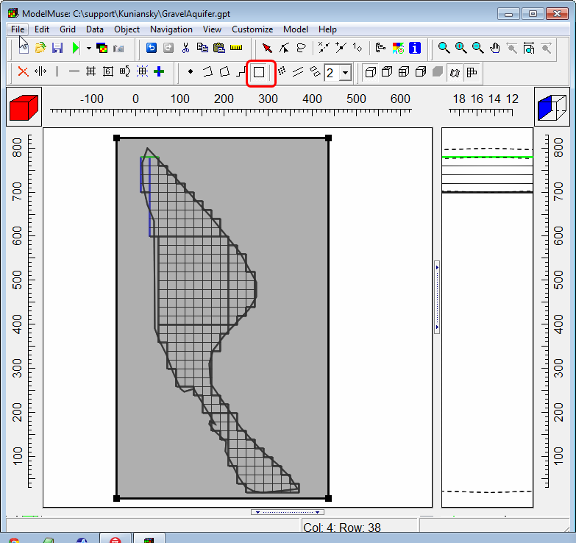



In the Object Properties dialog box, go to the MODFLOW Features tab and activate the Recharge package. Specify the starting and ending time and the recharge rate. (By default, the model has a single, steady-state stress period that starts at -1 and ends a 0.) If you wish, you may give a name to this object on the Properties tab to make it easier to recognize it later on.  
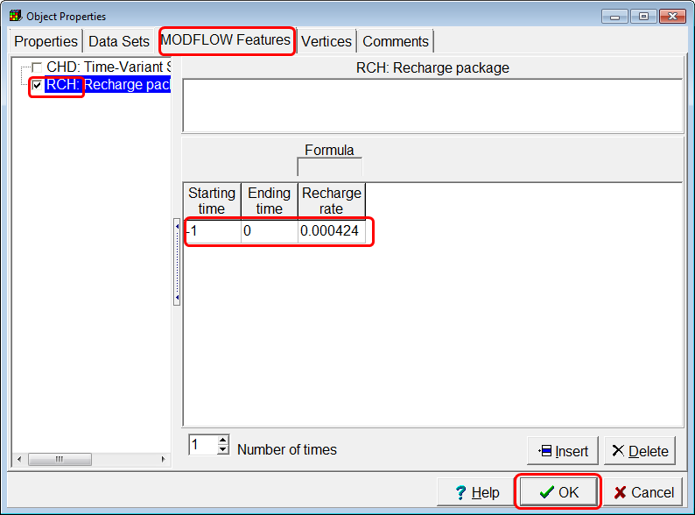

# Defining the Constant Head Boundary

Lets hide the object that specifies the recharge. Click the “Show or hide objects” button.  
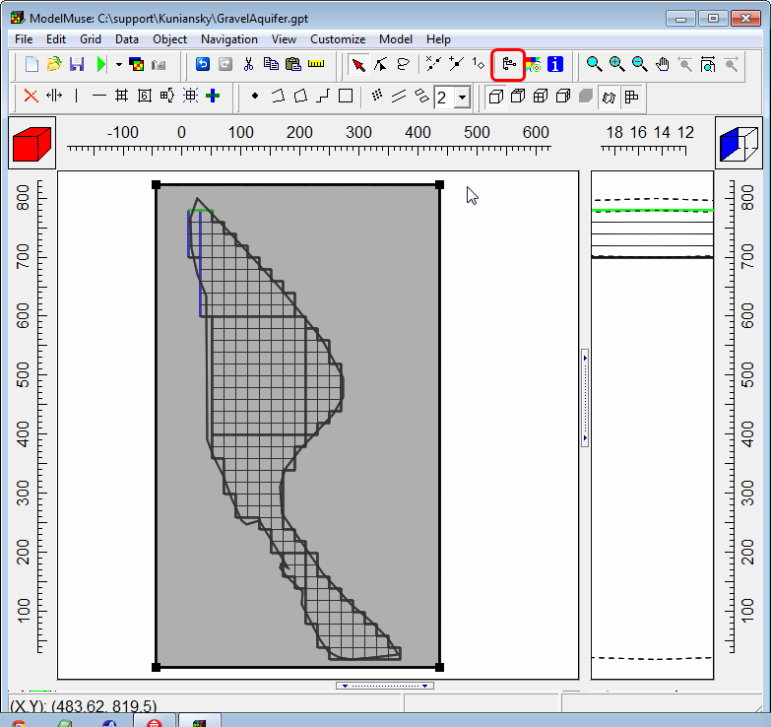

Uncheck the checkbox for the object that specifies the recharge to hide it.

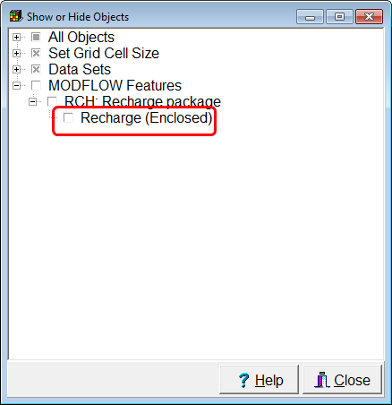

Select “Object|Select Objects” and click on the object that defines the grid cell size. Then select “Edit|Copy” to copy this object to the clipboard.  
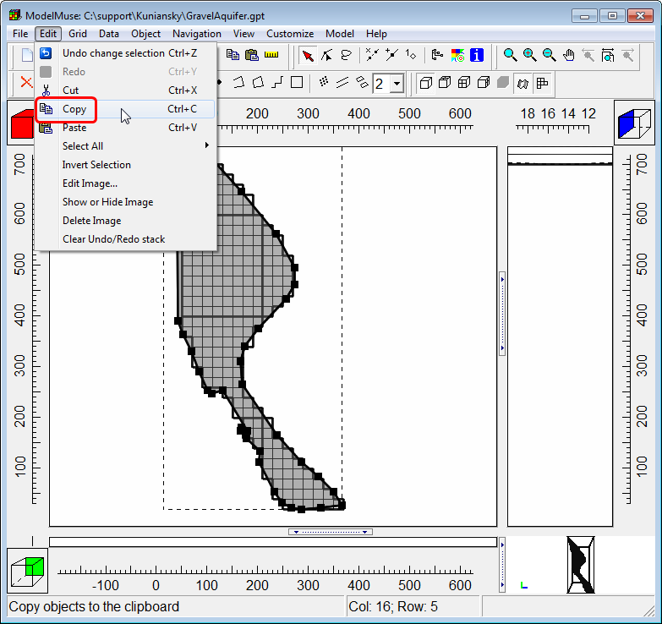

Now select “Edit Paste” to paste a copy of the object back into the model.  
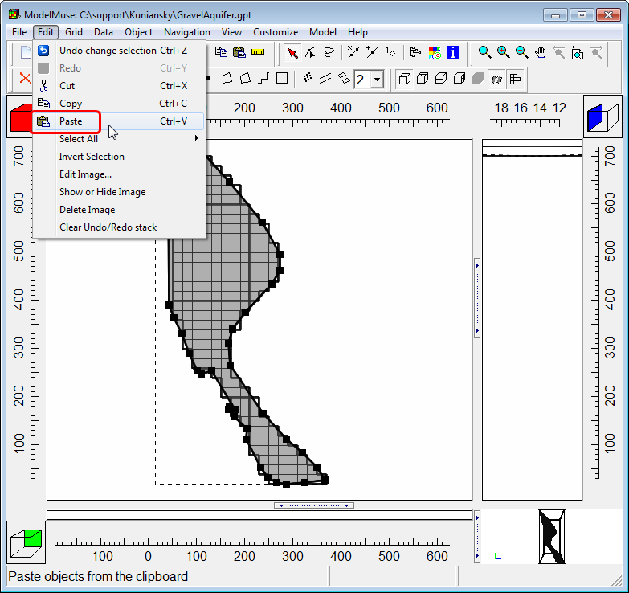

Hide the object that specifes the grid cell size.

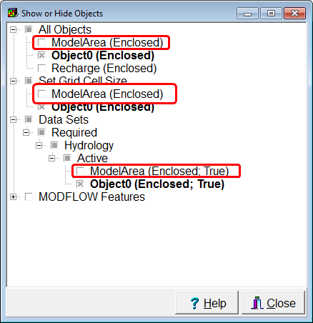

We will use the object we copied from the clipboard to define the river. However, we will have to modify it so that it only includes that part of the object that is along the river. Click the “Delete segment” button  and click on one of the segments on the right side of the object to delete that segment.  
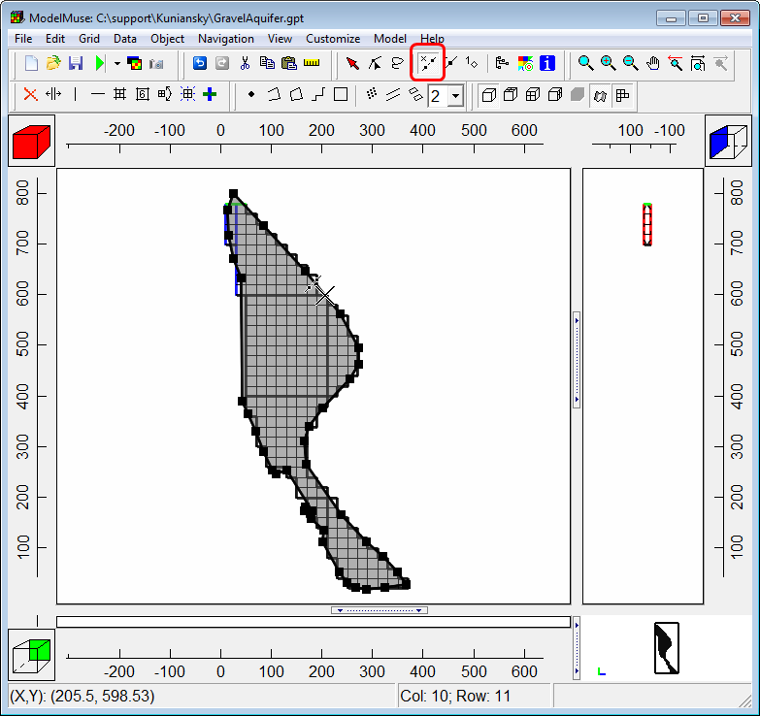

The object has been converted from a polygon to a polyline object but we still need to delete more of its vertices. Click the “Select vertices” button .  
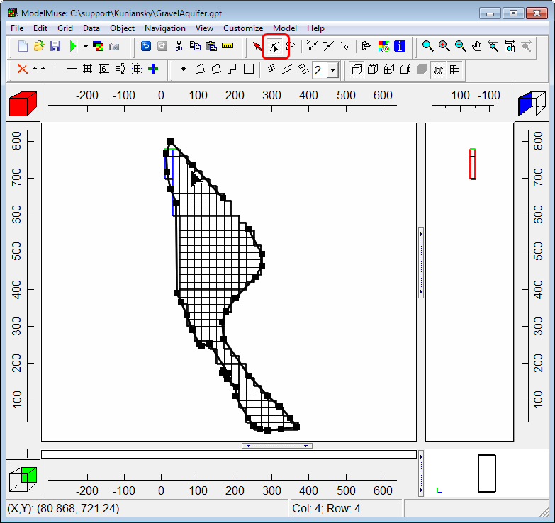

Now select the vertices that aren’t part of the river. Click the “Delete” button on the keyboard to delete the selected vertices. (To select the vertices, click on them or drag with the mouse around them.)

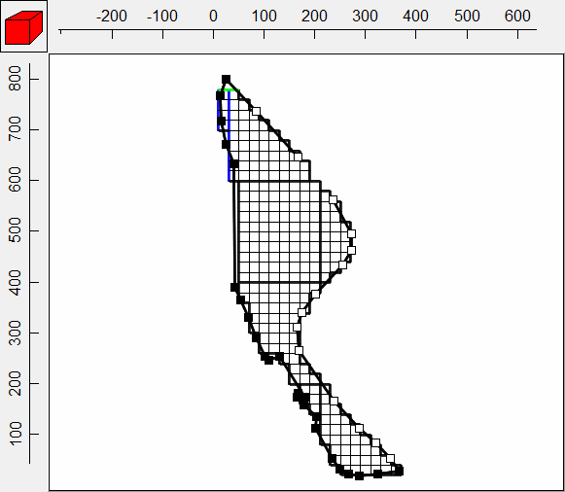

The object should now look like this.  
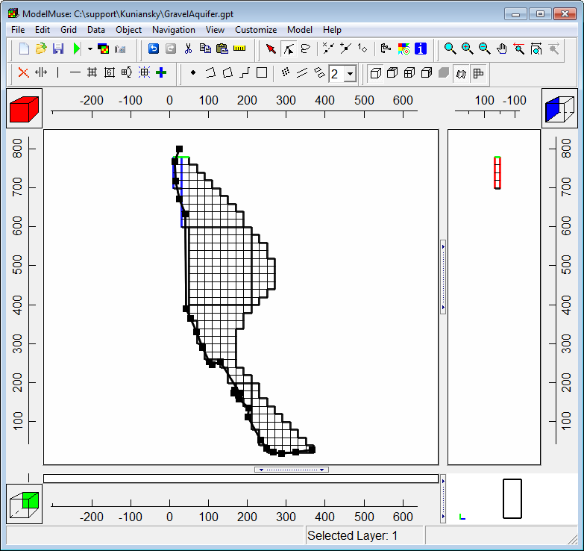

Select “Object|Select Objects” and double click on the polyline object. Check the “Set values of intersected cells check box.  
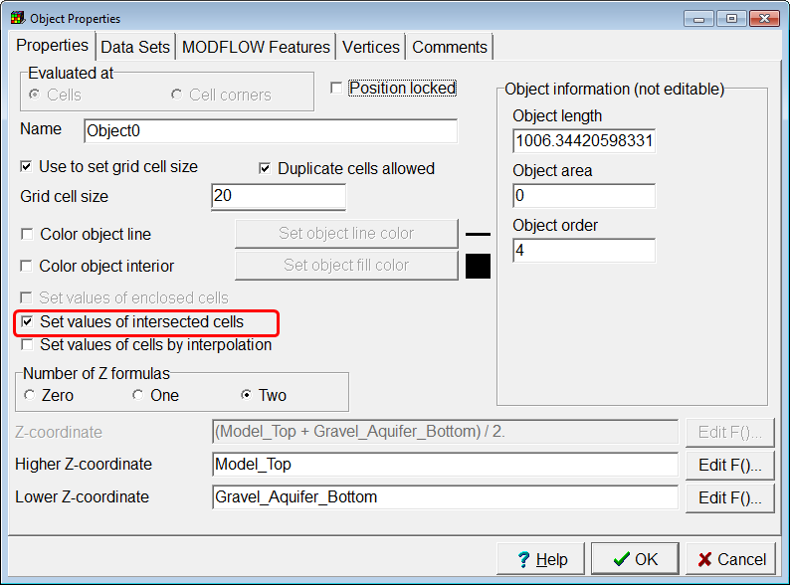

On the Data Sets tab, note that this object sets the Active data set to True.  
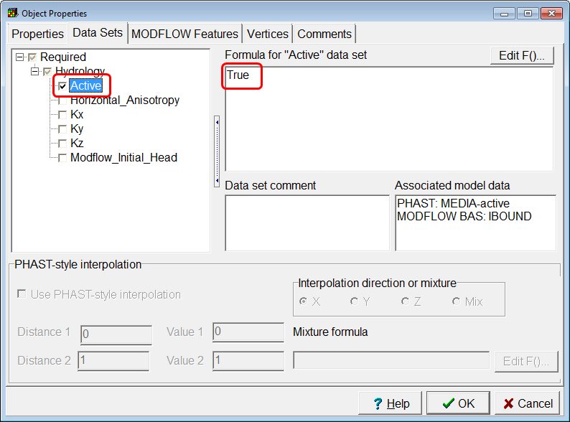

On the “MODFLOW Features” tab, check the check box for the CHD package and set the starting and ending times. You also need to specify formulas for the starting and ending head. Select the cell in the table for the starting head or ending head and a button will appear. Click the button to display the Formula Editor dialog box.  
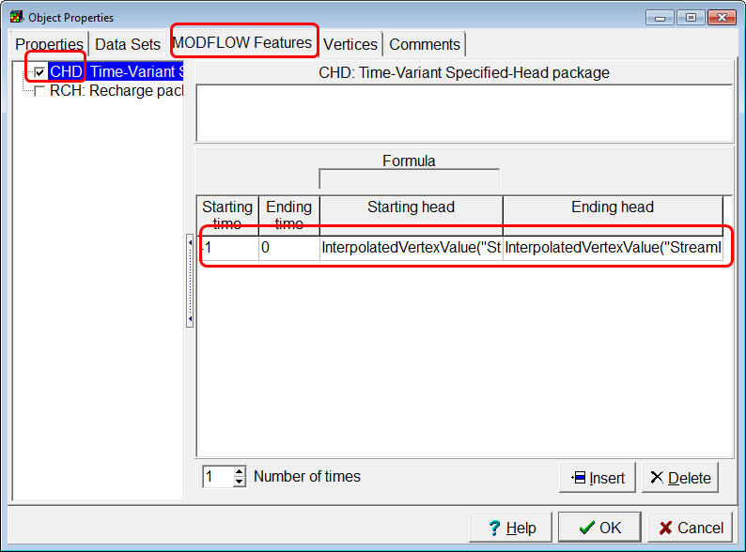

In the formulas editor set the formula to **InterpolatedVertexValue("StreamElevation")** and click OK. Use the same formula for both the starting and ending head.

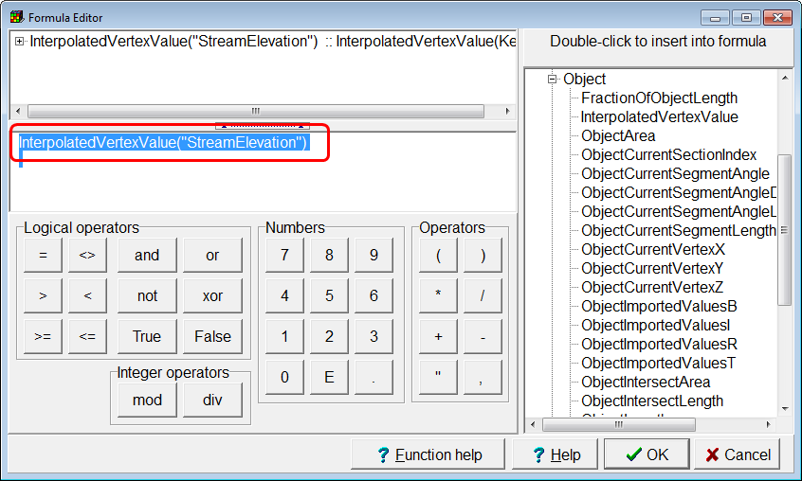

Click the “Edit vertex values” button . Then click on the vertex at the downstream (northern) end of the object that defines the river.  
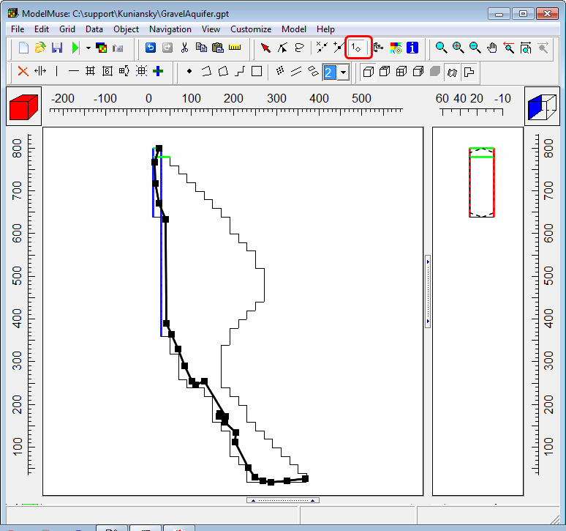

In the “Vertex Values” dialog box, enter the Key (“StreamElevation” and the value and click OK. Do the same for the vertex at the upstream end of the stream and enter the elevation for the upstream end. Remember that the length unit for this model is m.

**River Stage May 14, 1998  
average slope 0.00166**

|  |  |  |
| --- | --- | --- |
|  | ft | m |
| downstream | 62.01 | 18.89973 |
| upstream | 67.29 | 20.50899 |

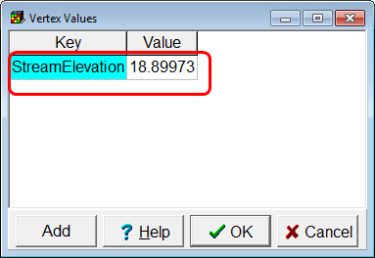

# Check the Specified Heads

To check that the elevations have been assigned correctly, we will color the grid cells with the value of the ending head. Click the “Data visualization” button .  
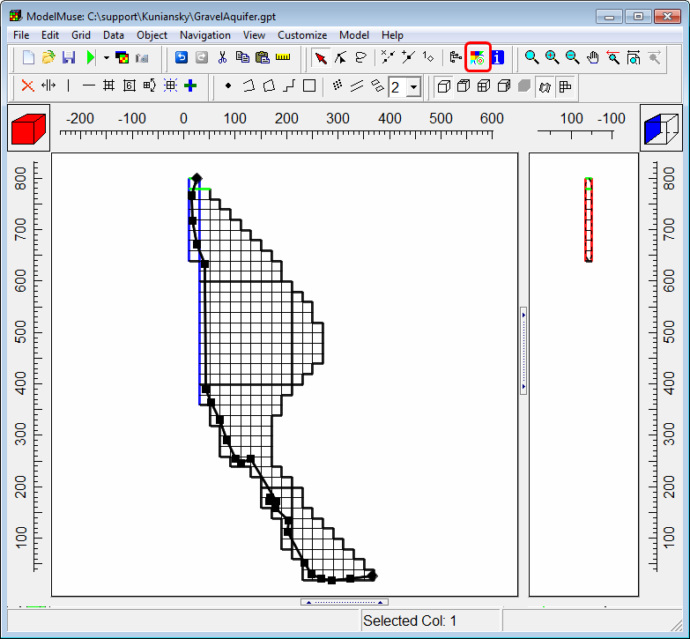

In the dialog box, select the CHD Ending head and click Apply.  
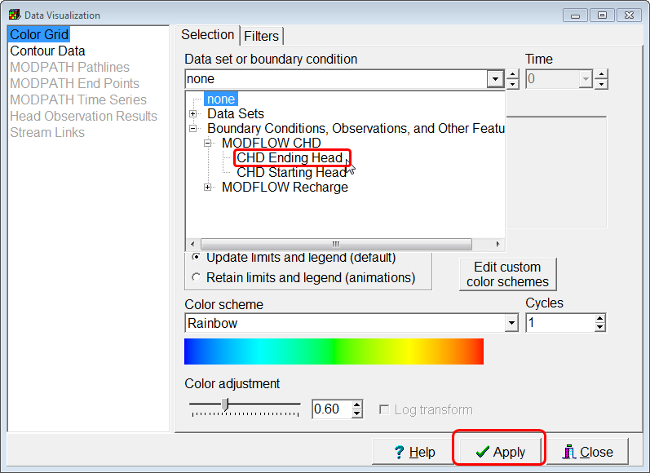

You should get something that looks similar to this. Next click the “Show grid values” button .  
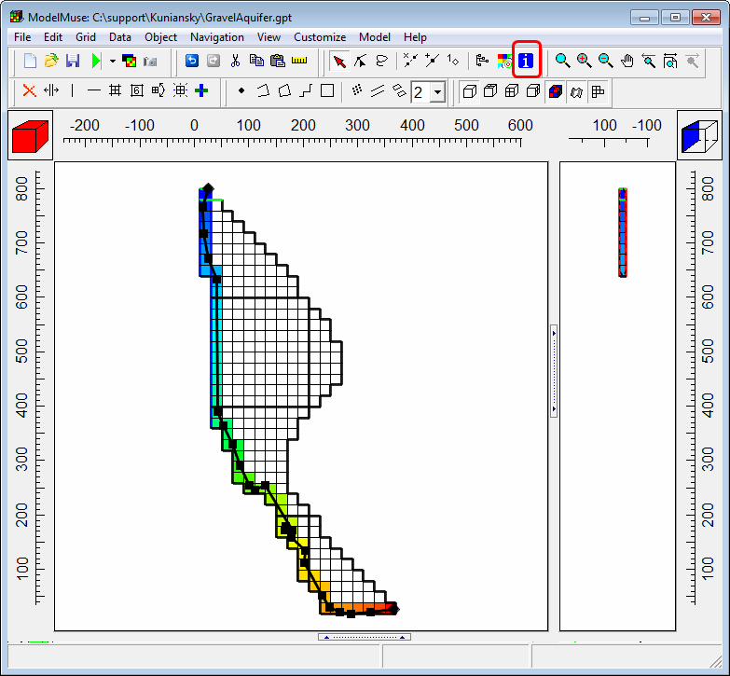

When you move the cursor over a grid cell, the value for that cell should appear along with an explanation of how that value was assigned.  
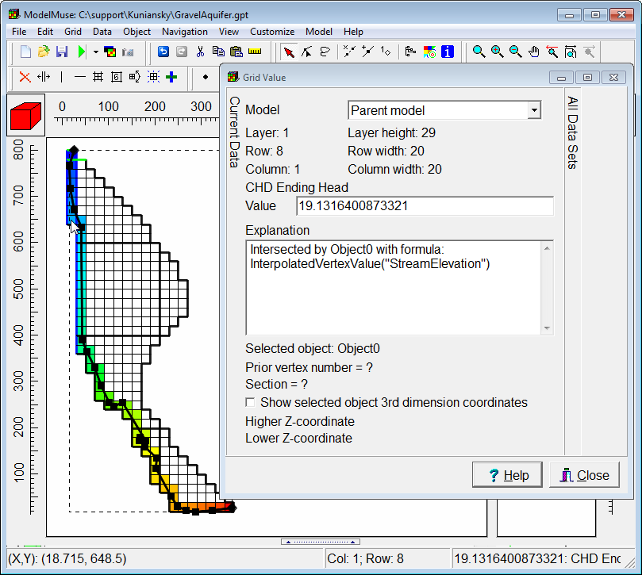

# Run MODFLOW

Now we are ready to run MODFLOW. Click the “Run MODFLOW” button  and save the input files.  
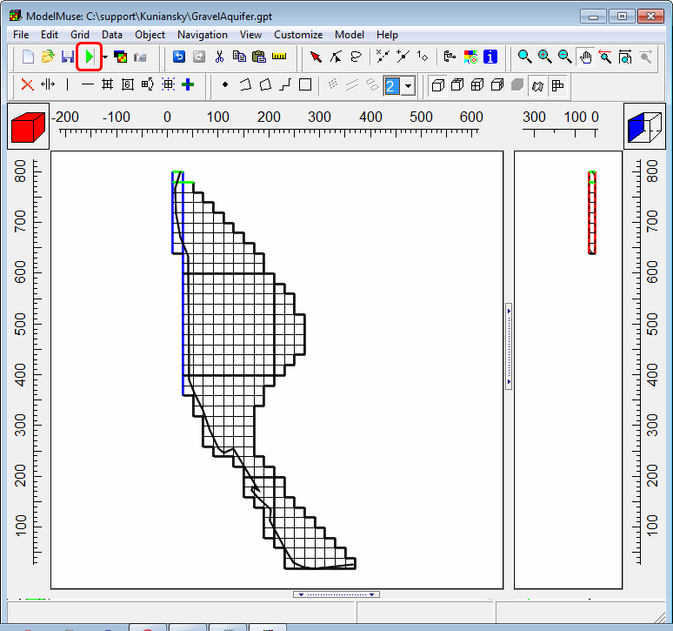

ModelMonitor will appear and show you information about the model as it is running. When the model is done running, close ModelMonitor. You can also close the MODFLOW listing file and the command line window that was used to run MODFLOW.  
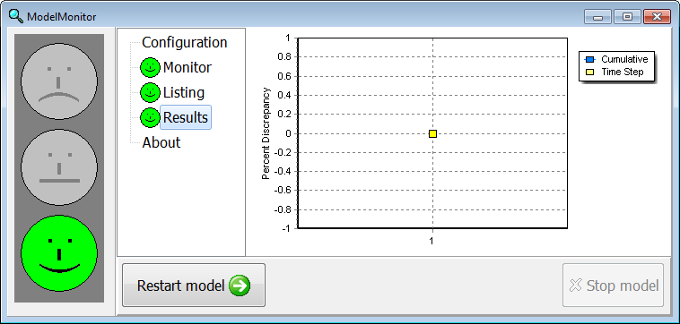

# Import Model Results

Next we will display the calculated heads. Click the “Import and display model results” button  and select the file with the heads. (It will have the extension .fhd. “Fhd” stands for “formatted heads.”)  
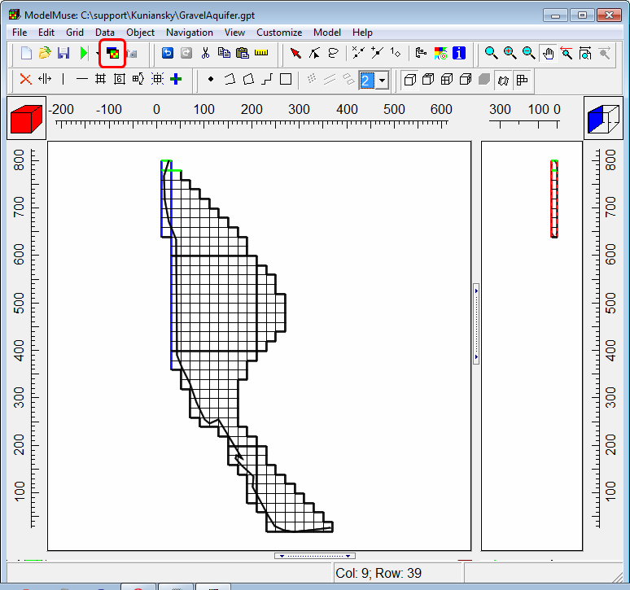

There is the one data set in the file. Select it. Click the “Contour grid” radio button. Select the data set used to color or contour the grid and click OK.

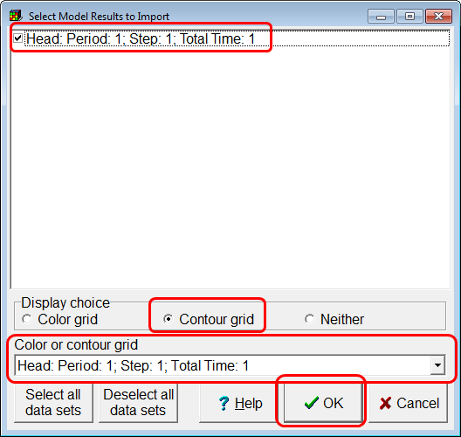

You should get something similar to this. 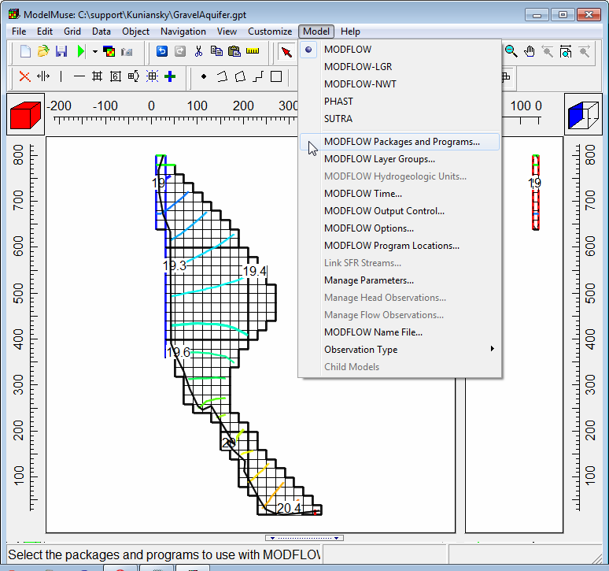

# Activate MODPATH

Next we will run MODPATH. Select “Model|MODFLOW Packages and Programs…”  
Activate MODPATH, set the output mode to “End points”. Check the “Use zone arrays” check box and set the zone in which particles will stop to 2.  
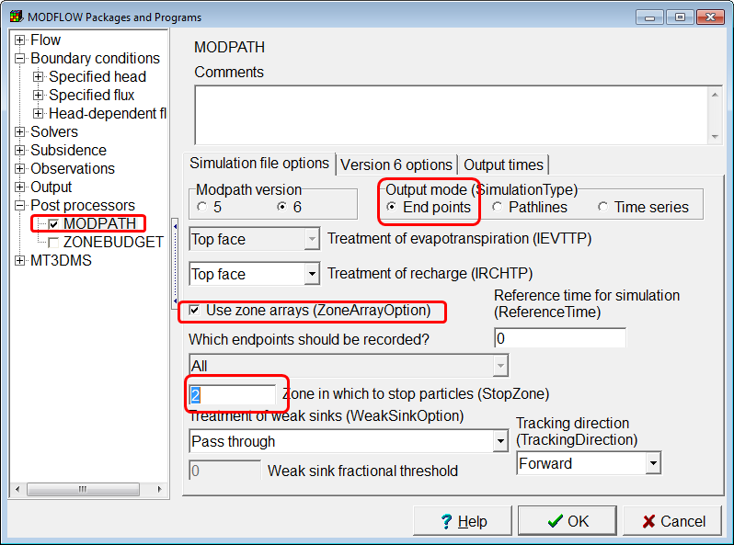

On the “Version 6 options” tab, choose to have the particles stop at termination points and click OK.  
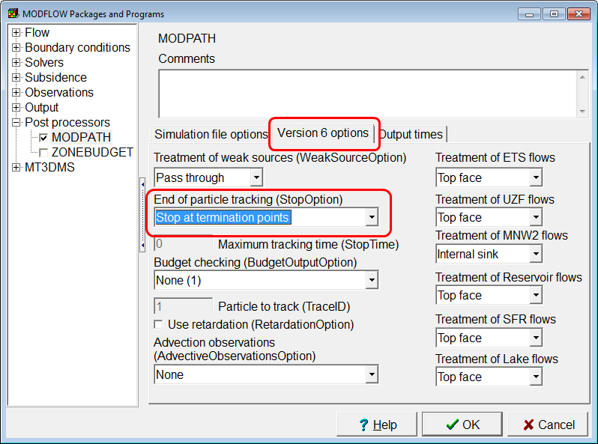

A warning will appear telling you that you need to change something in the format to the head file in the “Output Control” dialog box.

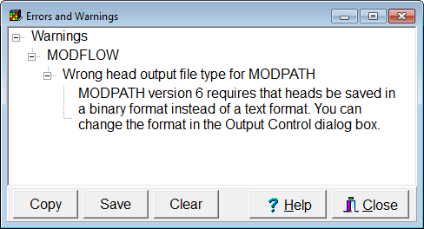

# Change the Output File Type

Select “Model|MODFLOW Output Control…”  
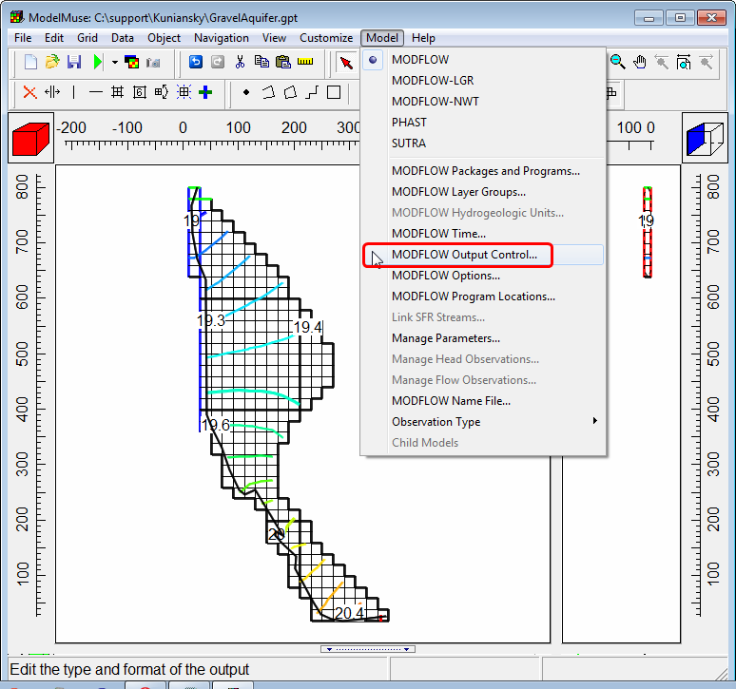

Change the external file type of the head file to “Binary”.

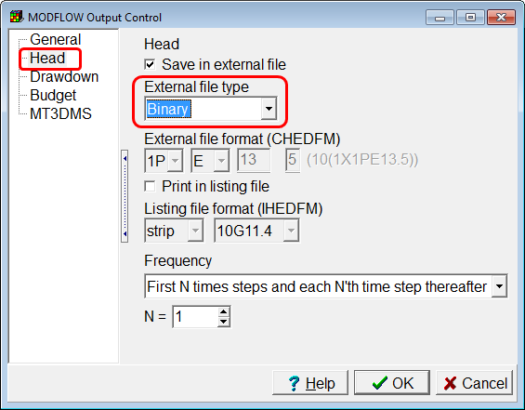

# Specify MODPATH Particle Starting Locations

Next we will specify the starting locations of the particles. Create a rectangle object that completely surrounds the mesh.  
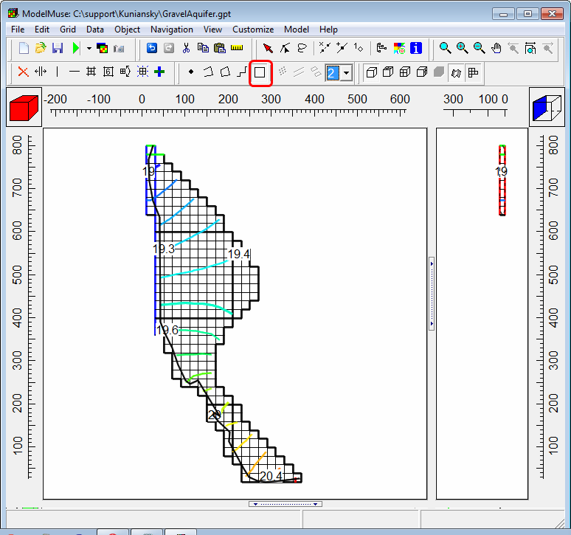

In the Object Properties dialog box, go to the MODFLOW Features tab and check the check box for the Initial particle placement for MODPATH. Specify that the particles are on the top face of the cells with 2 particles in the x direction and 2 in the y direction. Then click OK.  
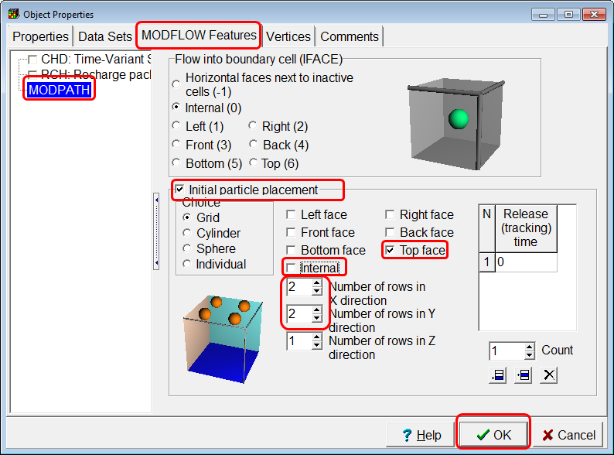

# Specify Particle Stopping Zone

Show the base map again by selecting “Edit|Show or Hide Image.” and use a polygon object to trace the outline of the area that sometimes is flooded by the river.   
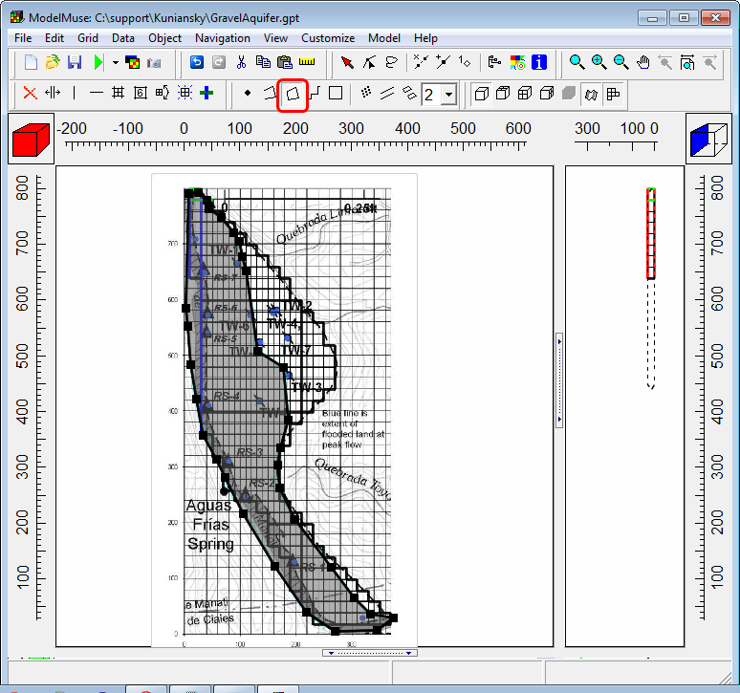

In the Object Properties dialog box, set the Modpath_Zone to 2. Then click OK.   
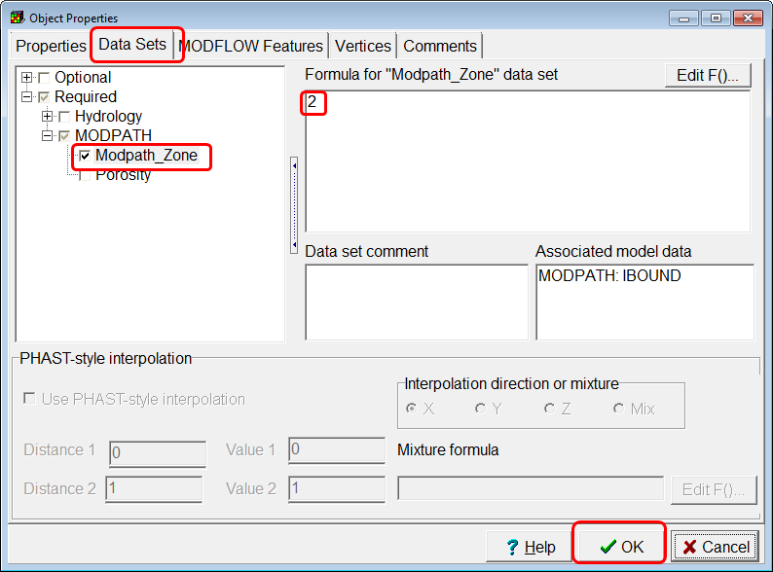

# Run MODPATH

Because we changed the format for the head file we have to run MODFLOW again. However, this time, we will also run MODPATH. In the dialog box, check the check box for exporting the MODPATH input files and MODPATH will run after MODFLOW is done running. You could run MODPATH without running MODFLOW by selecting “File|Export|MODPATH input files.

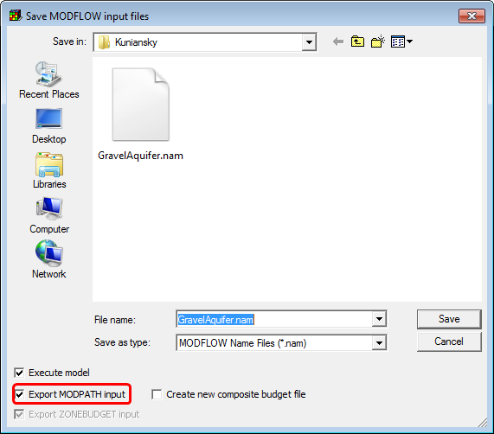

When MODPATH is done running, the command line window should show that MODPATH had a “Normal termination”. Close the command line window when MODPATH is done.  
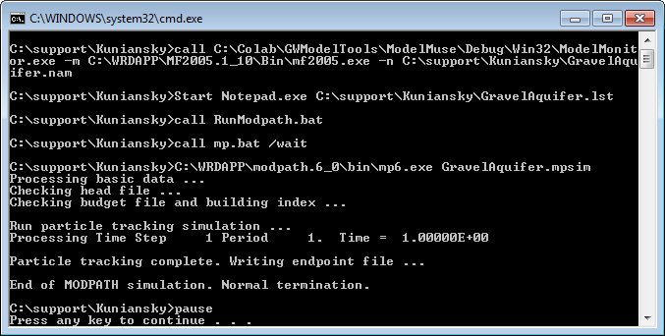

# Import MODPATH Results

Now we will display the MODPATH results. Click the “Data visualization” button .  
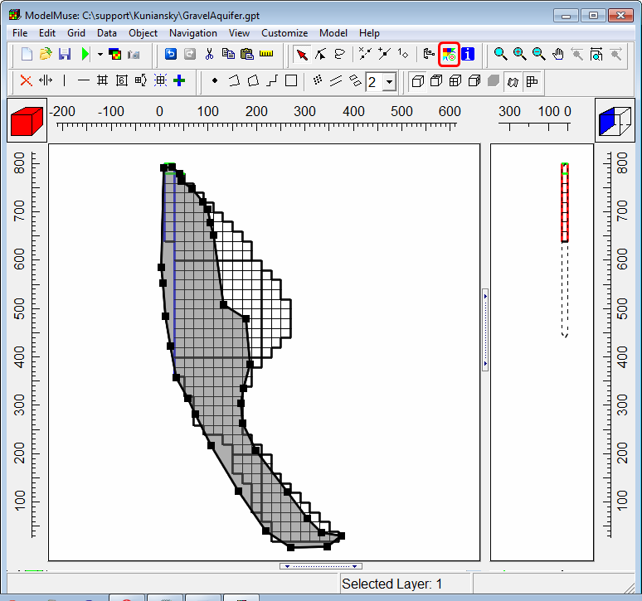

Go to “MODPATH End Points” and select the endpoint file. Make sure that the “Show endpoints” check box is checked.  
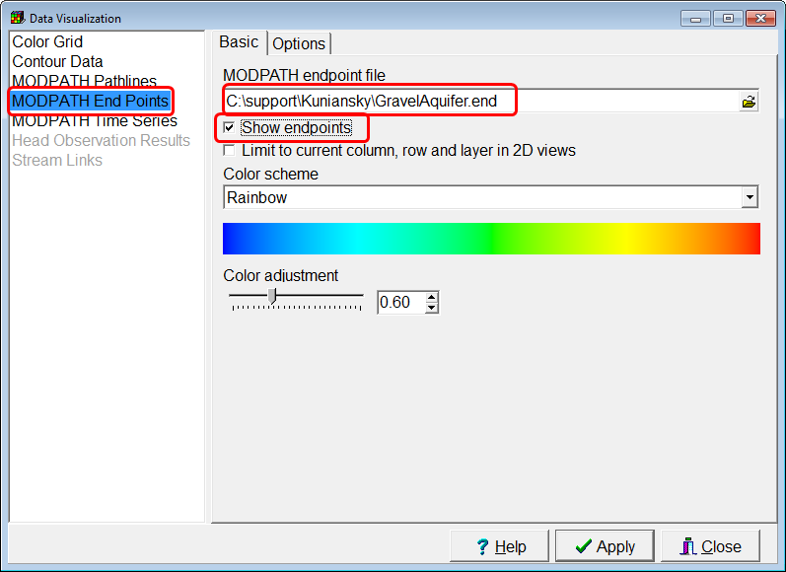

On the “Options” tab, chose to plot the end points at their starting locations and color by tracking time. Instead of showing all the particles, limit which particles are displayed. Set the minimum tracking time to 60 days and the maximum zone to 1. Click Apply.  
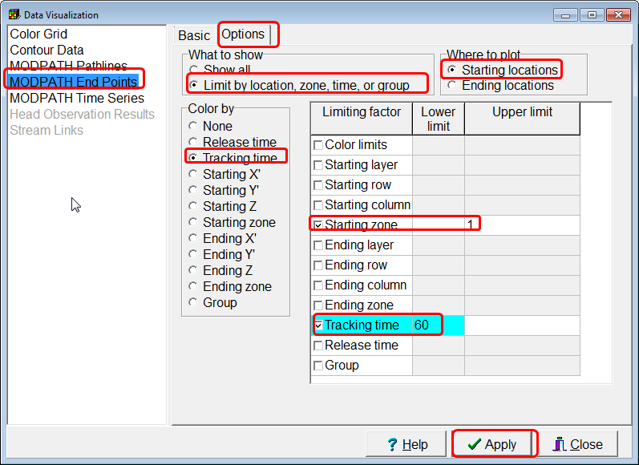

The colored particles are plotted at locations that have travel times to the river of 60 days or more. The red particles have the longest travel times. These locations are all potential locations for a water-supply well. However, the pumping from the well will change the flow field. Before selecting a final well location, you will need to modify the model to include the proposed well and then run both MODFLOW and MODPATH again to make sure that the travel time to the river is 60 days or more.  
